**Payroll file consolidation update**

**IMVP64**

MVP Name: **IMVP64 - Payroll file consolidation update**

Solution design document (SDD)

##### Version 1.0

RESTRICTED DISTRIBUTION

The information is standard Company Confidential but due to its sensitivity it has restricted distribution and viewing within the respective recipients.

Document Version Control

|  |  |  |  |
| --- | --- | --- | --- |
| **Date Issued** | **Version** | **Description** | **Author** |
| July 08, 2025 | 1.0 | Initial version to be submitted for ARB review. | Arpitha Puli |

Reference Documents

|  |  |
| --- | --- |
| **Document link** | **Reference usage** |
| [PDD](https://wizzaironline.sharepoint.com/:w:/r/teams/CLMProject-DiscoveryPhase/Shared%20Documents/IMVP64%20-%20Payroll%20file%20consolidation%20update/Discovery/PDD%20-%20IMVP64%20-%20Payroll%20file%20consolidation%20update.docx?d=w18e38923a22a4bc9a2236c41ffbe2f05&csf=1&web=1&e=npU0dv) | Process Definition Document including information on the to-be business process flow, automation in-scope and out of scope |
| [Automation COE S-IAD](https://wizzaironline.sharepoint.com/:w:/r/teams/CLMProject-DiscoveryPhase/Shared%20Documents/General/5%20Delivery/04%20Solution%20Design%20(SDD)/0%20Infrastructure%20Solution%20Architecture%20S-AID/S-IAD/Automation%20COE%20-%20S-IAD.docx?d=w14fd3542b36a4c299bc7f1f707a68b57&csf=1&web=1&e=AyDLi2) (enterprise solution and infrastructure architecture diagram) | Enterprise IPA Solution and Infrastructure Design -high level document. Represents the IPA technology stack, IPA VMs infrastructure setup, and the bot interaction points with on-premises applications involved in the automation. |
| [IPA CoE – Infrastructure Inventory](https://wizzaironline.sharepoint.com/:x:/r/teams/CLMProject-DiscoveryPhase/Shared%20Documents/General/5%20Delivery/Inventory/Infra%20and%20licenses%20inventory/ACE%20Infrastructure%20inventory.xlsx?d=we1898c745a5d473d876285cc14bca4a7&csf=1&web=1&e=0g94Mf) | IPA Virtual Machines, Service accounts, MS Power Automate licenses, Software, NAS / shared folders mapping inventory for IPA DEV, UAT and Production environments. |

Document Sign-off Requirements.

The following table contains the people required to review and/or sign-off this document and those that require the document for information only.

|  |  |  |
| --- | --- | --- |
| **Name** | **Department** | **Responsibility** |
| Havadi Farkas Joachim | Digital Transformation and Innovation – Architecture | Review, Sign-off |
| Nagy Abris | Cyber Architect | Review, Sign-off |
| Abel Kaszian | GDP – Data Protection Officer | Review, Sign-off |

Contents

1. Introduction 5

2. To-be Solution Design 6

2.1. Source and target systems 6

2.2. To-be Solution Design 6

2.3. Risks / Issues 9

2.4. Assumptions 9

2.5. Dependencies 9

2.6. Clarifications 9

2.7. Automation reusable components 10

2.8. Exceptions handling – business and technical exceptions 11

3. Automation logs 12

4. Non-functional requirements 12

4.1. Transaction volume, Average handling time 12

4.2. Solution Scalability 12

4.3. IPA infrastructure capacity plan 12

4.4. Bot run schedule plan 13

5. Information and Data Security 13

5.1. User role and permissions 13

5.2. Data classification 13

6. Appendix A: 15

# 

**Acronyms**

|  |  |
| --- | --- |
| Acronym | Description |
| IPA | Intelligent Process Automation |
| CLM | Crew Life Cycle Management |
| SDD | Solution Design Document |
| ARB | Architecture Review Board |
| PAD | (Microsoft) Power Automate Desktop |
| BCP | Business Continuity Plan |
| DRP | Disaster Recovery Plan |
| MVP | Minimum Viable Product (scrum release deliverable to production) |
| MS | Microsoft |
| PII | Personally Identifiable Information |
| CLW | Crew Lifecycle Workflow |
| API | Application Programming Interface |
| PDP | Pre-Delivery Payment (schedule) |
| API | Application Programming Interface (web service) |
| GDP | Group Data Protection |
| DPO | Data Protection Officer |
| AHT | Average Handling Time / Processing time |
| EY | Ernst & Young |

# Introduction

The as-is process flow and to-be process flow is documented in detail in the [PDD](https://wizzaironline.sharepoint.com/:w:/r/teams/CLMProject-DiscoveryPhase/Shared%20Documents/IMVP64%20-%20Payroll%20file%20consolidation%20update/Discovery/PDD%20-%20IMVP64%20-%20Payroll%20file%20consolidation%20update.docx?d=w18e38923a22a4bc9a2236c41ffbe2f05&csf=1&web=1&e=npU0dv). The PDD contains:

* Step by step information involved in the as-is process flow
* non-functional requirements related to transaction volumes, processing time expectations, bot execution scheduling (frequency and run schedule)
* to-be process flow with process steps that will be part of automation scope and those out of scope.

The PDD is signed off by the business SME.

The Solution Design Document (SDD, this document) captures the technology solution aspects that are specific to the MVP deliverable that this SDD pertains to.

The document will be presented for review and approval from:

Enterprise Architecture Review Board represented by Havadi Farkas Joachim who will be single point of contact for review and sign-off (typically 2-3 business days from review submission date).

1. Applications technical leads of application relevant to the MVP scope (case by case basis), in this case Cyber Security and DPO are part of automation’s review and sign-off scope of work.

# To-be Solution Design

The to-be solution design details the applications / interfaces involved in the automation scope of work, to-be business process flow, solution design related risks/issues/assumptions and dependencies.

## Source and target systems

|  |  |  |
| --- | --- | --- |
| Source / Target | Application name | Store the response from Microsoft form |
| Source | Excel | To get payroll details of employees |
| Target | SQL Database | Store payroll details |
| Target | Email | MS Graph API:  Send email notification to ACE operations and business teams upon bot run completion / failure. |
| Source | Power Apps | 1, To Upload Payroll files |
| Target | Cloud flow | 1, To trigger desktop flow on an ad-hoc basis |
| Target | PAD flow | 1, Save uploaded files to the network drive.  2, Map the columns based on the country file uploaded  3, Consolidate block hours for the month they upload.  4 Consolidate data from crew files based on their position.  5. Consolidate data from the GTN file. |

## To-be Solution Design

High level system architecture design is presented in the diagram below, also stored at Teams [link](https://wizzaironline.sharepoint.com/:p:/r/teams/CLMProject-DiscoveryPhase/Shared%20Documents/IMVP64%20-%20Payroll%20file%20consolidation%20update/SDD/IMVP64%20-%20Payroll%20file%20consolidation%20update%20To-Be%20Solution%20Architecture%20Design.pptx?d=w93771dee4c4c4d0e98be58e6dc9d7ec8&csf=1&web=1&e=wG5Vv1):

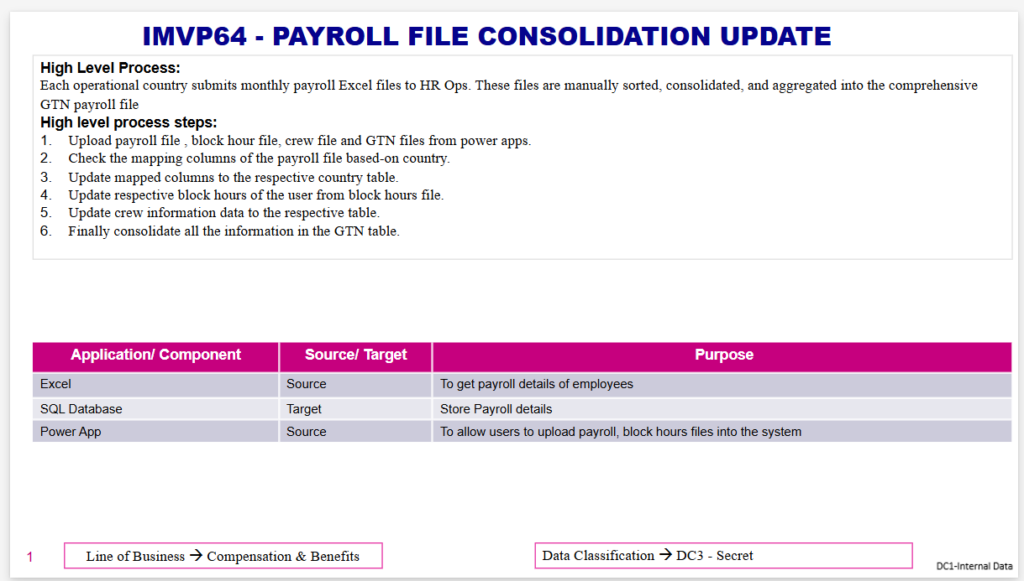

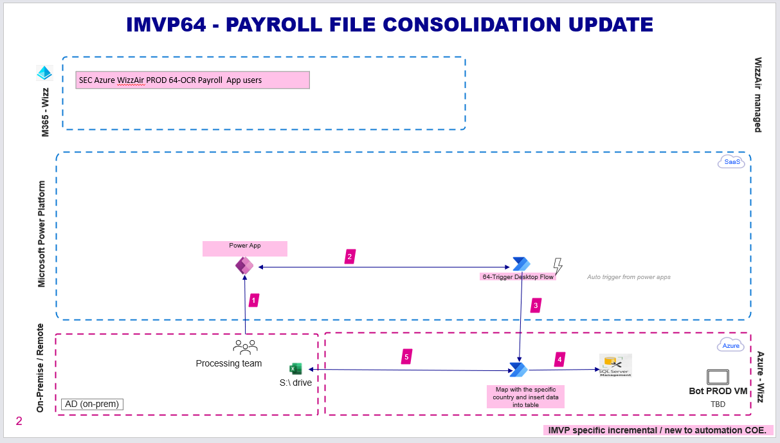

## Detail Architecture Steps

Step1: Inputs: Power Apps **Outputs**: Excel File

* Select the category (payroll file, Block hours, Crew file, GTN file) of which file user is uploading.
* If a user has uploaded Payroll file, then make the user select which countries payroll they are uploading.
* If a user has uploaded a file with more than one sheet, then make the user select which sheet must be considered for processing.

**Step2,3,4:** Inputs: Excel File **Outputs**: SQL DB

* Open the excel uploaded by the user

1. If the file is a payroll file, then map the columns based on the country user selected.
2. After mapping the columns, insert the respective columns data into the respective country table.
3. For other types of files, insert the data directly into the respective Database tables.

* If the user has uploaded a block hours file, then consolidate block hours into the payroll country table for the respective months.
* If the user has uploaded the Crew file, then consolidate all the crew info like flying hours, landed info, etc. into the payroll country table for the respective months.
* Consider the type of crew file based on the position of the employee. If an employee is cabin crew, consider crew file else captain file.
* After copying all the data calculated the total gross salary and total net salary.

**Note:** BA developed VBA code as part of this process. It has nothing to do with the BOT. Before uploading the file into PowerApps, users will use this VBA Code to clean up the data. As the structure of file changes for every country, they will use this VB code, and they will Format the file into the structured one and will upload it into PowerApps. Provided the links below for the detailed steps and VB code excel.

[VB Code Detailed code](https://wizzaironline.sharepoint.com/:w:/r/teams/IMVP64Devs/Shared%20Documents/IMVP64%20Development%20chat/SDD%20POC%20Ext.%20-%20IMVP64%20-%20Payroll%20file%20consolidation%20update.docx?d=w727b1ea73c4141438b6c905077095916&csf=1&web=1&e=cvFpii)

[IMVP64 - VB Automation.xlsm](https://wizzaironline.sharepoint.com/:x:/r/teams/IMVP64Devs/Shared%20Documents/IMVP64%20Development%20chat/IMVP64%20-%20Payroll%20file%20and%20consolidation%20update%20-%20Excel%20automation.xlsm?d=wa843af20421442148770d7f42f27c862&csf=1&web=1&e=eemrqA)

* Need to do development and UAT with dummy files by mimicking real scenarios but not real data

The standard MS Power Platform system architecture that applies to Power Platform at Wizz Air as well can be referred to at this [link](https://docs.microsoft.com/en-us/power-platform/guidance/expressroute/understanding-architecture).

**The to-be solution will include:**

1. Environmental Variables

|  |  |
| --- | --- |
| Environment variables | Config File Path |

1. Configuration File

|  |  |
| --- | --- |
| Configuration File | Maintain the configuration file in the Shared Folder as per the standard. All the constant key values can be included here.  Few Keys given below:  File Paths  Retry count.  Helpdesk Email  Business SME email  <This can be reviewed and finalized before UAT> |

1. Power Platform Environment:

|  |  |
| --- | --- |
| Development Environment | Wizz Air Automation CoE Development |
| Testing Environment | Wizz Air Automation CoE Testing |
| Prod Environment | Wizz Air Automation CoE Production |

1. Dataverse Security:

|  |  |
| --- | --- |
| Access Level | Steps:   1. NA |
| Storage | NA |

1. SharePoint Security:

|  |  |
| --- | --- |
| Authorized users and groups: | 1. NA. |

1. Share Folder Environment:

|  |  |
| --- | --- |
| Development Environment | \\wizzair.local\wizzairdn2\AutomationCoE\Bot\DEV |
| Testing Environment | \\wizzair.local\wizzairdn2\AutomationCoE\Bot\UAT |
| Prod Environment | \\wizzair.local\wizzairdn2\AutomationCoE\Bot\PRODSTAGING |

1. SharePoint Environment:

|  |  |
| --- | --- |
| Development Environment | NA |
| Testing Environment | NA |
| Prod Environment | NA |

1. Power Apps

A new Canvas app will be created which will be used to Upload excel file with SQL table as data source.

1. AI Model

NA

1. AI Builder Credits

NA

1. Power Platform Request

Total Power platform request: ~1000 request per day

Power platform request calculated based on Total Actions, Document Types and Avg Volume per day.

1. Power Platform components

|  |  |
| --- | --- |
| Flow Type | Purpose |
| Cloud flow | 1, To trigger desktop flow on an ad-hoc basis |
| PAD flow | 1, Save uploaded files to the network drive.  2, Map the columns based on the country file uploaded  3, Consolidate block hours for the month they upload.  4 Consolidate data from crew files based on their position.  5. Consolidate data from the GTN file. |

## License Requirements

Process schedule and frequency: Ad-hoc trigger. Whenever a user upload files using PowerApps.

Power Automate Cloud Flow: Existing Service Account will be used to run the flow. No new license is required.

## Risks / Issues

**SQL Server:**

* If the database server or port has no changes, then it needs to be informed to change at the BOT level.
* Once bot inserted the data into the table in the SQL Server, business needs to verify it from their end to check the outcome of the BOT report.

**Mitigation:** Business will review the data and if there is something wrong with the BOT then they will update the correct data into the input file and reupload the file back in power apps and bot will trigger automatically and correct the data.

* In phase 2, the requirement will cover the editing row option in power apps.

**TAT:** As soon as business updates the right information in power apps. BOT will trigger and update the information into the fare manager (as and when)

## Assumptions

* This section should highlight the assumptions that are considered and agreed upon with stakeholders.
* Developers will get access to Dev VMs and VMs have all necessary access and license to Power platform.
* The business team will be provided with the test data and test documents for SIT and UAT testing.
* The business team will be available to test, review deliverables, and sign off.

## Dependencies

This section highlights the dependencies that the process has along with description.

|  |  |  |  |  |  |  |
| --- | --- | --- | --- | --- | --- | --- |
|  | Dependency | Priority | Ownership | Need by | Status | Notes |
| 1 | SQL DB | High | Paul/Richard | Before Development Start | WIP |  |
| 3 | UAT and Production VM and service accounts | High | Paul, Tamas | Before development completed | Open |  |

## Clarifications

### Q&A affecting finalization of SDD preparation / review / sign-off

|  |  |  |
| --- | --- | --- |
| Question | Ownership | Status |
| NA | NA | NA |

### Q&A that do not affect finalization of SDD preparation / review / sign-off

|  |  |  |
| --- | --- | --- |
| Question | Ownership | Status |
| Bot run frequency | BA | Ad-hoc |
| Finalization of output summary report template | BA | In progress. |
| The data retention period must be finalized. | BA | NA |

## Automation reusable components

The Re-usable components are usually common tasks used across business processes. This is based on the concept of “Develop Once, use it elsewhere” or “Don’t Repeat Yourself (DRY)". The reusable components to be used for automation in this case are listed below:

|  |  |
| --- | --- |
| Component name | Usage purpose |
| Global logger | Automation log file centralized in Dataverse. |
| Bot prerequisite validator (on/off configurable) | To validate system and source/target application requirements availability in bot VM. It is useful to run for the first time and later when VM migration is performed from on-premises to Cloud. |
| Initialization | Template flow to read configuration file and initialize variables.  Bot's standard template design includes this function that will take care of checking whether the applications that the bot depends on are open, if not then launch/open the applications including Outlook app in this case.  Kill / close application was applicable on the bot VM before the bot begins fresh run. |

## Exceptions handling – business and technical exceptions

The exceptions are error scenarios that could occur while the App is being used. The exceptions are categorized into Business and Technical.

Business exception - errors occurring due to inconsistency with email attachment, reports, files templates and/or data.

Technical exception –other: errors from source / target applications that bot is trained to capture errors and log.

Technical exception bot - errors that do not fall under the above 2 categories, generally these are unhandled errors that the bot needs to go through continuous improvement.

|  |  |  |  |  |
| --- | --- | --- | --- | --- |
| Exception Category | Exception name | Bot action | Mitigation action | Bot communication |
| Business | Input inconsistent -SQL Tables Availability | BOT Execution moves to SQL tables updating | ACE ops support checks if Dataverse tables exist or not and provides a fix.  Business approves ACE ops support to run the bot on-demand for AI Builder Model Execution  ACE ops run the bot on-demand. | ACE Ops support:  Helpdesk@wizzair.com  Business operations team:  TBD |  |
| Business | Access issue – SQL DB | Bot execution moves to get SQL action. | CE ops support informs SQL IT support.  SQL, IT provides a fix  Businesses approve ACE ops support to run the bot on-demand for SQL. ACE ops run the bot on-demand. | ACE Ops support:  Helpdesk@wizzair.com  Business operations team:  TBD |  |
| Technical | Input inconsistent – SQL Tables Column Availability | BOT Execution moves to SQL tables updating | ACE ops support checks Dataverse tables Columns exist or not and provides fix.  Business approves ACE ops support to run the bot on-demand  ACE ops run the bot on-demand. | ACE Ops support:  Helpdesk@wizzair.com  Business operations team:  TBD |  |
| Technical | Input inconsistent – Input data mismatch | BOT Execution moves to SQL tables updating | ACE ops support checks whether data is correct or not provides a fix.  Business approves ACE ops support to run the bot on-demand  ACE ops run the bot on-demand. | ACE Ops support:  Helpdesk@wizzair.com  Business operations team:  TBD |  |

# Automation logs

This MVP uses the standard automation of COE enterprise logging capabilities.

# Non-functional requirements

Non-functional requirements pertain to transaction volume, average handling time, and SLA expectations of the to-be automated process.

## Transaction volume, Average handling time

|  |  |
| --- | --- |
| # of items processed/reference period | 17+ entities X 1 file (min.) X 12 months + 3 files X 12 months = 240 files, |
| Peak period | Annual salary review |
| Transaction volume during peak period | NA |

## Solution Scalability

The bot will run PAD flow on Azure VM.

## IPA infrastructure capacity plan

The bot will run PAD flow on Azure VM. It will use the existing VM available in the production environment.

## Bot run schedule plan.

Proposed – ad hoc trigger the flow from PowerApps.

# Information and Data Security

## User role and permissions

Access to O365, Power Platform environment, automation bot VMs and share folders will be granted access to the automation app service accounts. For security reasons, separate service accounts will be used for DEV, UAT and PROD environments (same account will not be shared across environments). Automation delivery team members with an individual name user account will not need access to the above-mentioned items.

Role-based access control:

|  |  |  |  |
| --- | --- | --- | --- |
| User | User role | Access requirement | Access request procedure |
| BOT SA (TBD) | Read Write | SQL DB WizzAir.GTN-RAW | Special request form and  Helpdesk ticket. |

## Data classification

DPO review checklist [here](https://wizzaironline.sharepoint.com/:x:/r/teams/CLMProject-DiscoveryPhase/Shared%20Documents/IMVP64%20-%20Payroll%20file%20consolidation%20update/SDD/DPO%20checklist%20-%20IMVP64%20-%20Payroll%20file%20consolidation%20update.xlsx?d=we96c876d11a945109648745d282c26af&csf=1&web=1&e=xbsWnc).

**Data classification category is mentioned below.**

|  |  |
| --- | --- |
| **Data Classification** | Depending on campaign content |
| DC0 - Public data |  |
| DC1 - Internal Data |  |
| DC2B - Confidential business data |  |
| DC2P - Personal data |  |
| DC2S - Sensitive personal data |  |
| DC3 – Secret | X |

|  |
| --- |
| **Informational Data classification enterprise guideline:** |
| DC0 - Public data: Public data is data that can be disclosed to the public without harm. Public data has no authentication or authorization requirements. |
| DC1 - Internal Data: Internal data includes most organizationally produced documents, files, emails, and other essential material for day-to-day operations - material that should be restricted outside of an organization. Even so, unauthorized access to such material would not cause irreparable harm to that organization. |
| DC2B - Confidential business data: unauthorized disclosure of such information could cause loss of privacy, competitive advantage, reputation, revenue, damage to partnerships and relationships and may lead to moderate financial loss. Also, data which is extremely sensitive or strategic to Wizz Air. |
| DC2P - Personal data: any information relating to an identified or identifiable natural person (‘data subject’); an identifiable natural person is one who can be identified, directly or indirectly, in particular by reference to an identifier such as a name, an identification number, location data, an online identifier or to one or more factors specific to the physical, physiological, genetic, mental, economic, cultural or social identity of that natural person. |
| DC2S - Sensitive personal data: personal data revealing racial or ethnic origin, political opinions, religious or philosophical beliefs, or trade union membership, genetic data, biometric data for the purpose of uniquely identifying a natural person, data concerning health or data concerning a natural person’s sex life or sexual orientation. |
| DC3 - Secret: Electronic or physical data which is extremely sensitive or strategic to Wizz Air. Unauthorized disclosure of such information could lead to serious consequences and impact the revenue, safety or reputation of Wizz Air. Secret data must be made available only to named individuals or specified positions. Information Assets handling such electronic data/information must be classified as ‘Secret’. |

# Appendix A:

Not applicable.